TMT/ Chennai /991/2026 31.03.2026

To,
E ARULKUMAR
Sri Saravana Body Works Chennai - 600056, TN
Click to call: +91-9841003889
+91-44-24768140
E-mail: srisaravanabodyworks@yahoo.in , e.arulkumar@hotmail.com

Dear Sir

SUB :- SUPPLY OF 400 MT DISHEND FORMING HYDRAULIC PRESS

With reference to our discussions regarding your requirement for press. we are glad to inform you that, we are in a position to supply you the required equipment. The following are the specifications and our terms and conditions.

Specifications of the equipment

Technical Specifications :-

Pressing cylinder

❖ Max Working Pressure - 200 Kg/cm2
❖ Normal Working Pressure - 160 Kg/cm2
❖ Design Pressure - 250 Kg/Cm2
❖ Tonnage at 100 Kg/cm2 - 100 Tons
❖ Cyl Bore - 500 mm
❖ Rod Dia - 350 mm
❖ Stroke - 600 mm
❖ Mtg - Front Flange
❖ Approach Speed - 35 mm/sec
❖ Pressing Speed - 0-5 mm/sec
❖ Return Speed - 44 mm/sec
❖ HP - 40 HP
❖ Tank Cap - 600 Ltr

Detail Bill of Material

❖ Cylinder Seals - Imported German Seals ( Merkel or Halite )
❖ Motor - ABB / Siemens / Kirloskar / Crompton
❖ Rod Seal - Imported halite Seal
❖ Valves - Yuken / Polyhydron / Hydrotech
❖ Check Valves - Polyhydron
❖ Hydraulic Pump - Yuken / Dowty
❖ High Pr Pump - Polyhydron
❖ Bell Housing - Micro
❖ Relief Valves - Polyhydron
❖ Hyd Tank - Micro
❖ Hyd Tank - MHPL
❖ Fitting - Hyloc / Hydair
❖ Gasket - Champion
❖ Fastners - TVS / LPS

S No | Description of the unit | Offer
1. | Dish end forming press with 400 Ton Capacity with stroke 600 mm and daylight 1200 mm along with electrical panel and power pack.  Along with | Rs 66,70,000/- (Rupees Sixty-Six lakhs seventy thousand only)

GENERAL TERMS & CONDITIONS:

1. Price quoted per unit ex-work. Hyderabad.
- Following charges are additional to your account.
- Freight Charge : As actual to be borne by you.
- Excise : Extra As Applicable
- Sales Tax : Extra as applicable
- Packing charge : As actual to be borne by you.
- Insurance : As actual to be borne by you.
- Payment : 50% advance along with order balance before delivery but after inspection at our works.
- Delivery :With 50% advance 2 months from date of advance received
- Validity : One month from the date of submission.
- Inspection : Inspection at our works prior to dispatch.
- Warranty : The machine is warranted for a period of 12 months from the date of dispatch against any manufacturing defects/ faulty material or bad workmanship of any part or component but not against any kind of abnormal or improper use of machine. Defective part or component will be replaced or repaired free of cost. Electrical components are outside the scope of this warranty.
- Commissioning : Erection & commissioning done by you, but required technical support & guidance provide by us at additional cost.

NOTE:
- Oil is not in scope of our supply.
- Raw material for trial is to be arranged by you at your cost.

We are sure you will find our offer in line with your requirements. Should you require any further clarification please contact 9246221106

Thanking you and assuring you of our best services
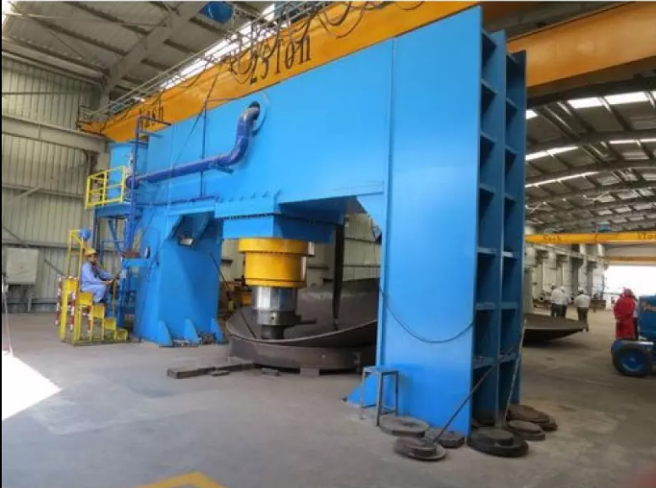

For TECHNO MACHINE TOOLS

( T. SIVARAMAKRISHNA)

TMT/ Chennai /S0728/2026 31.03.2026

To,
E ARULKUMAR
Sri Saravana Body Works Chennai - 600056, TN
Click to call: +91-9841003889
+91-44-24768140
E-mail: srisaravanabodyworks@yahoo.in , e.arulkumar@hotmail.com

Dear Sir,

Sub: - Supply of Three Roller Plate Bending machine Pyramid type

We thank you for your inquiry regarding Plate Bending machine for MS plate width 3000 and thickness 12 mm. We are glad to inform you that we would be in a position to do the required equipment. Given below are the specifications and description of the machine and our terms and conditions.

Specifications of the equipment

1) Maximum width of the plate that can be rolled : 3000 MM

2) Maximum thickness of the plate that can be rolled : 12 MM

3) Top Roll diameter : 275 MM

4) Bottom Roller Diameter : 260 MM

5) Minimum Rolling Diameter : 490 MM

6) Rolling speed : 3.0 Meters/Min.

7) Maximum yield limit of the plate : 245 Mpa.

8) Total power : 10 HP

S No | Description of the unit | Offer
1. | Supply Three Roller Plate Bending machine for 3000 X 12 MM along electrical. | Rs 6,16,000/- (Six Lakhs Sixteen Thousand Only)

GENERAL TERMS & CONDITIONS:

- Price quoted per unit ex-work. Hyderabad.
- Following charges are additional to your account.
- Freight Charge : As actual to be borne by you.
- Excise : Extra As Applicable
- Sales Tax : Extra as applicable
- Packing charge : As actual to be borne by you.
- Insurance : As actual to be borne by you.
- Payment : 50% advance along with order balance before delivery but after inspection at our works.
- Delivery : Within 2 months.
- Validity : One month from the date of submission.
- Inspection : Inspection at our works prior to dispatch.
- Warranty : The machine is warranted for a period of 12 months from the date of dispatch against any manufacturing defects/ faulty material or bad workmanship of any part or component but not against any kind of abnormal or improper use of machine. Defective part or component will be replaced or repaired free of cost. Electrical components are outside the scope of this warranty.
- Commissioning : Erection & commissioning done by you, but required technical support & guidance provide by us at additional cost.
NOTE:
- Oil is not in scope of our supply.
- Raw material for trial is to be arranged by you at your cost.

We are sure you will find our offer in line with your requirements. Should you require any further clarification please contact 9246221106
Thanking you and assuring you of our best services
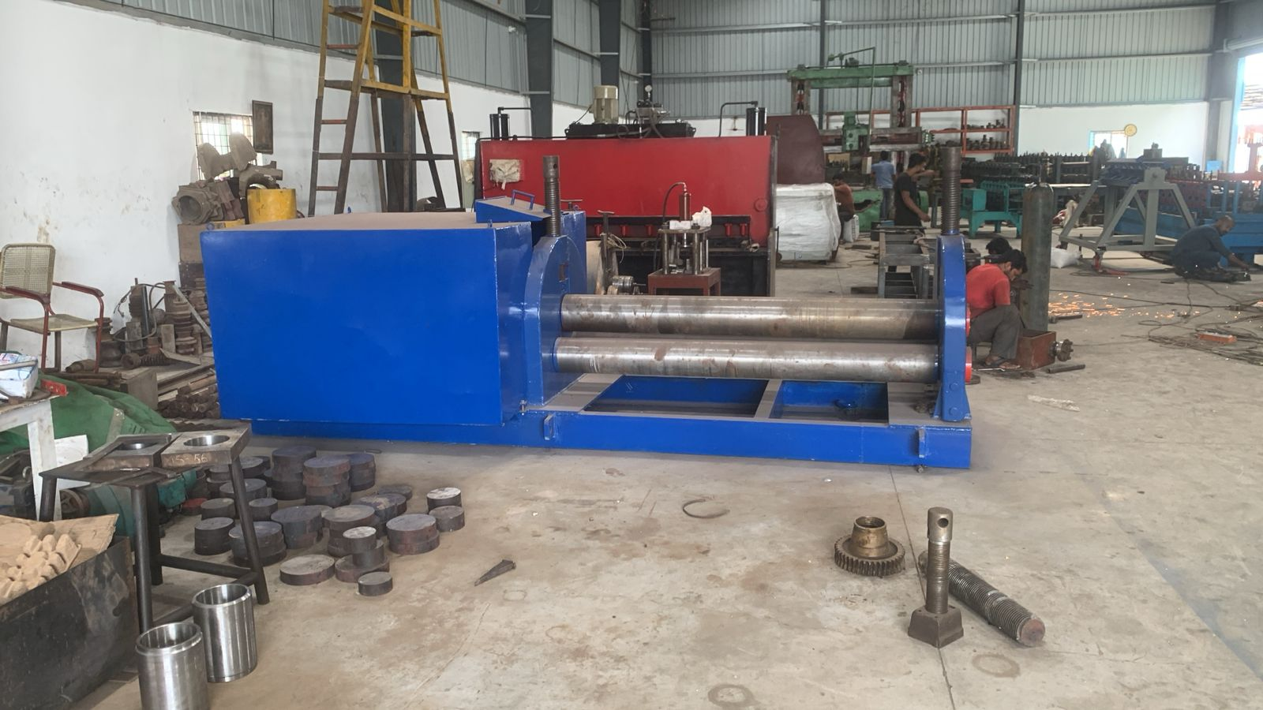

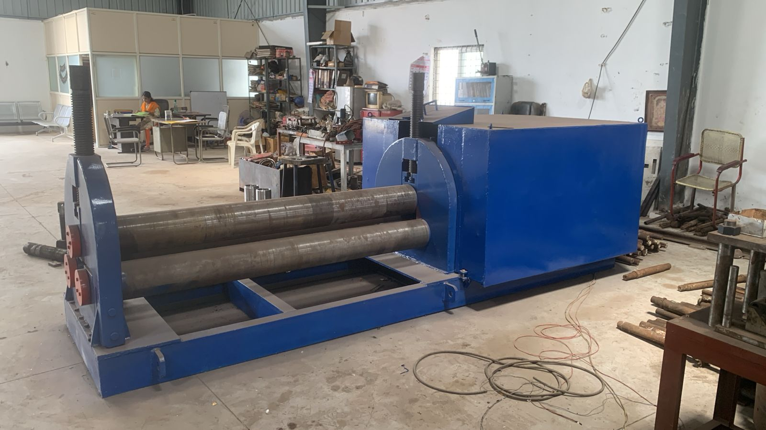

For TECHNO MACHINE TOOLS

(T. SIVARAMAKRISHNA)

